Vocabulary Weeks 1 - 2 Bell Ringer Sheet
Previous words: Achilles’ heel Mnemonic Fathom Tawdry Stentorian

- Serendipity (ser un DIP uh tee)
- Patriarch (PAY tree ark)
- Monarch (MON ark)
- Hierarchy (HY uh rar kee)
- Matriarch (MAY tree ark)

Monday – Draw an illustration for the NEW vocabulary words only.
Serendipity | Patriarch | Monarch
Hierarchy | Matriarch

Tuesday – Write the letter of the correct definition in the blank beside the vocabulary word.
_____ | 1. | Achilles’ heel | a. | assisting memory
_____ | 2. | Mnemonic | b. | Father or leader of a family, clan, tribe, or group
_____ | 3. | Fathom | c. | Make lucky discoveries by chance or accident
_____ | 4. | Tawdry | d. | Woman who rules a family, clan, tribe, or group
_____ | 5. | Stentorian | e. | understand, figure out, penetrate meaning of
_____ | 6. | Serendipity | f. | Person or things arranged in a series or rank
_____ | 7. | Patriarch | g. | Very loud
_____ | 8. | Monarch | h. | A ruler, like a king, queen, emperor, or sultan
_____ | 9. | Hierarchy | i. | weak point
_____ | 10. | Matriarch | j | showy and cheap

Wednesday – Use the vocabulary words in each of the following sentences.
- Because of nothing more than ____________________________, she was able to reconnect with her long lost love.
- The ___________________ of the tribe declared his intentions to have his daughter marry someone from a neighboring tribe.
- Wearing inappropriate clothing made the girl look _________________________.
- The math problem stumped the student, proving to be the _______________________.
- Using a ________________ strategy helped Joanna improve her spelling skills.
- The _________________________ is often a strong woman who is able to make decisions for her family.
- When selecting the students, the teacher used a ____________________ to rank them by their abilities.
- No matter how much he tried, Harold could not ________________ how the child got stuck in the fence.
- With a ____________________ blast from the trumpet, Nicholas played the school song.
- The current ______________ of England is a woman.

Thursday – Write a synonym for each of the vocabulary words.
Vocabulary word | Synonym | Vocabulary word | Synonym
Achilles’ heel |  | Serendipity
Mnemonic |  | Patriarch
Fathom |  | Monarch
Tawdry |  | Hierarchy
Stentorian |  | Matriarch

Friday – Complete the following cross word puzzle. Remember there is a quiz today!
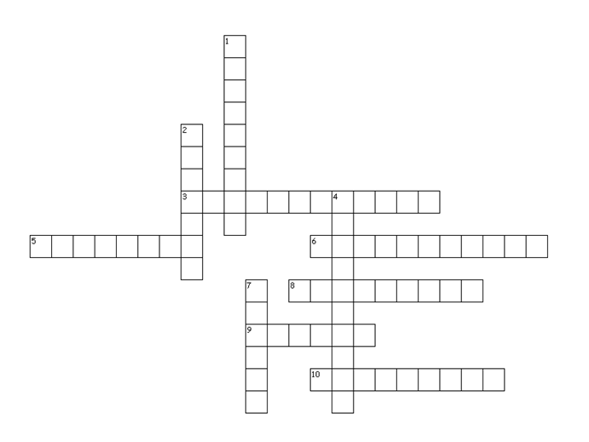
Across
3. weak point
5. assisting memory
6. make lucky discoveries by chance or accident
8. father, male leader of family, clan, tribe, group
9. showy and cheap
10. mother; female leader of family, clan, tribe, group

Down
1. person or things arranged in series or rank
2. a ruler; king, queen, emperor, sultan
4. very loud
7. understand, figure out, penetrate meaning

